DQL 2

- Display the average, lowest, highest and difference in lowest and highest salaries for each department number.

- Display the number of employees within each job.

- Display only those jobs where the minimum salary is greater than or equal to 3000.

- Calculate and display only the average salaries paid to all those employees where the employee name starts with A and name starts with S.

- Product exactly same output as shown below:

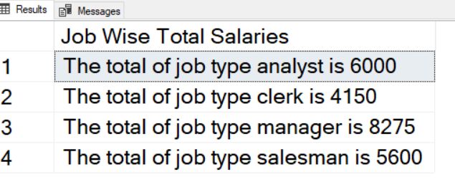

- Product exactly same output as shown below:

